Assignment -1

Create Visualizations
📊1.Bar Chart
1.Click Sheet 1.
2.Drag Category (or Name) → Columns.
3.Drag Value/Count → Rows.
4.A bar chart will be created.
5.Rename sheet as Bar Chart.
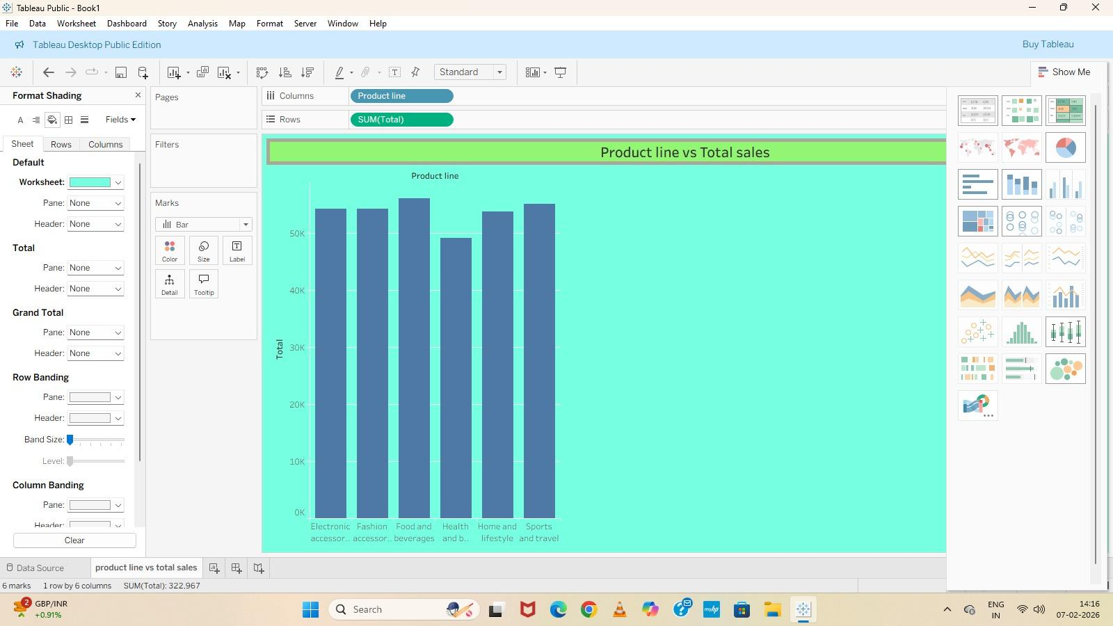
2. Pie Chart
1.Click New Sheet.
2.From Mark's dropdown → select Pie.
3.Drag Category → Color.
4.Drag Value → Angle.
5.Drag Value → Label.
6.Rename as Pie Chart.
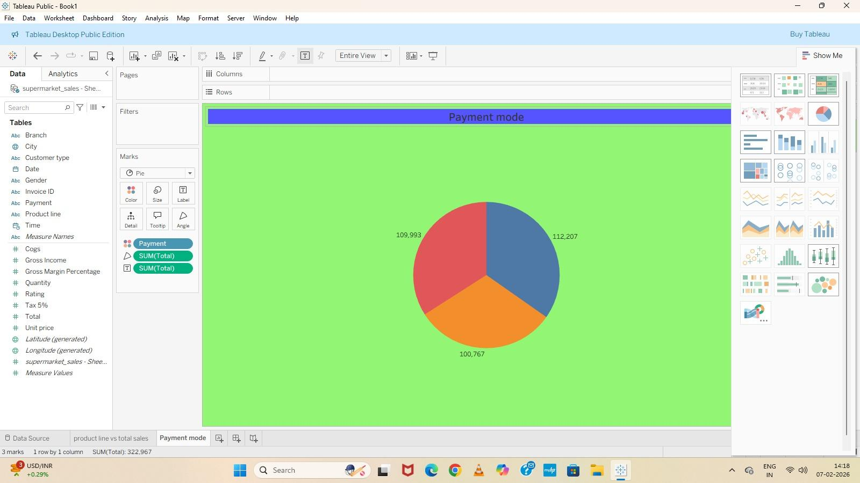
3. Stacked Bar Chart
1.Click New Sheet.
2.Drag Category → Columns.
3.Drag Value → Rows.
4.Drag Sub-category/Type → Color.
5.If not stacked:
6.Go to Analysis → Stack Marks → On
7.Renamed as Stacked Bar Chart.
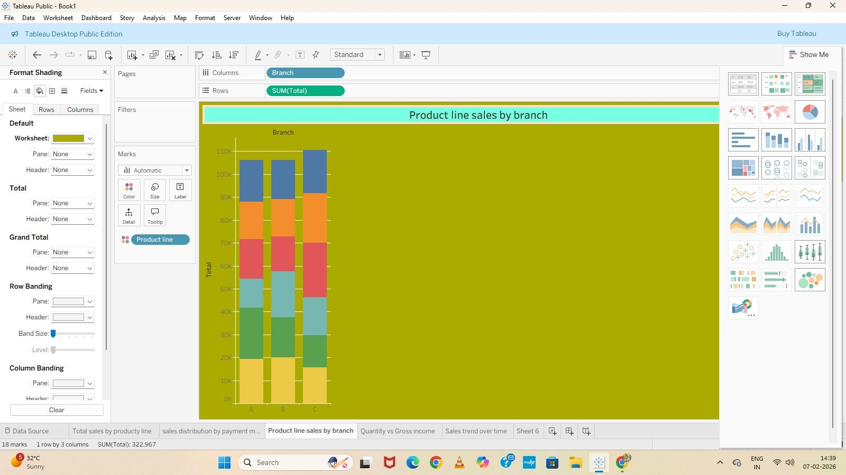
📈4. Line Chart
1.Click New Sheet.
2.Drag Date/Year → Columns.
3.Drag Value → Rows.
4.From Marks → select Line.
5.Rename as Line Chart.
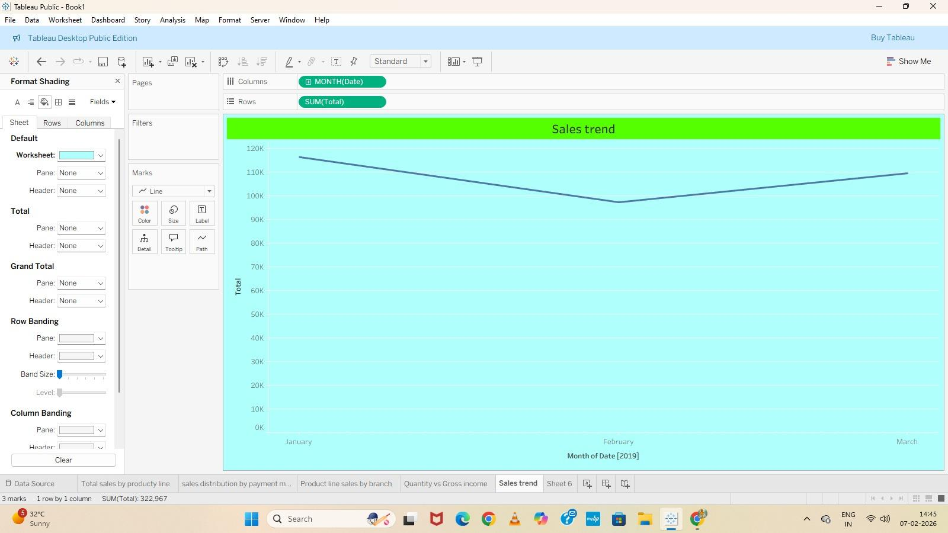
🔵5.Bubble Chart
1.Click New Sheet.
2.From Show Me → select Packed Bubbles.
3.Drag Category → Color.
4.Drag Value → Size.
5.Rename as Bubble Chart.
